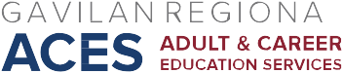

AB 104 Consortium Meeting
March 4, 2016
Agenda

I. Approval of Minutes of February 19, 2016

II. Updates/Reminders
- Marketing Socials
• Marketing-Entravision
• Professional Development Symposium
- MOU
- CASAS presentation
- Other?

IV. New Business
• 2016-17 Annual Plan/Budget

Next meeting: Friday, March 18, 2016, 2:30-4:30, HRC 101

